ANTWERP DIAMOND MANUFACTURERS AND TRADERS FAIR
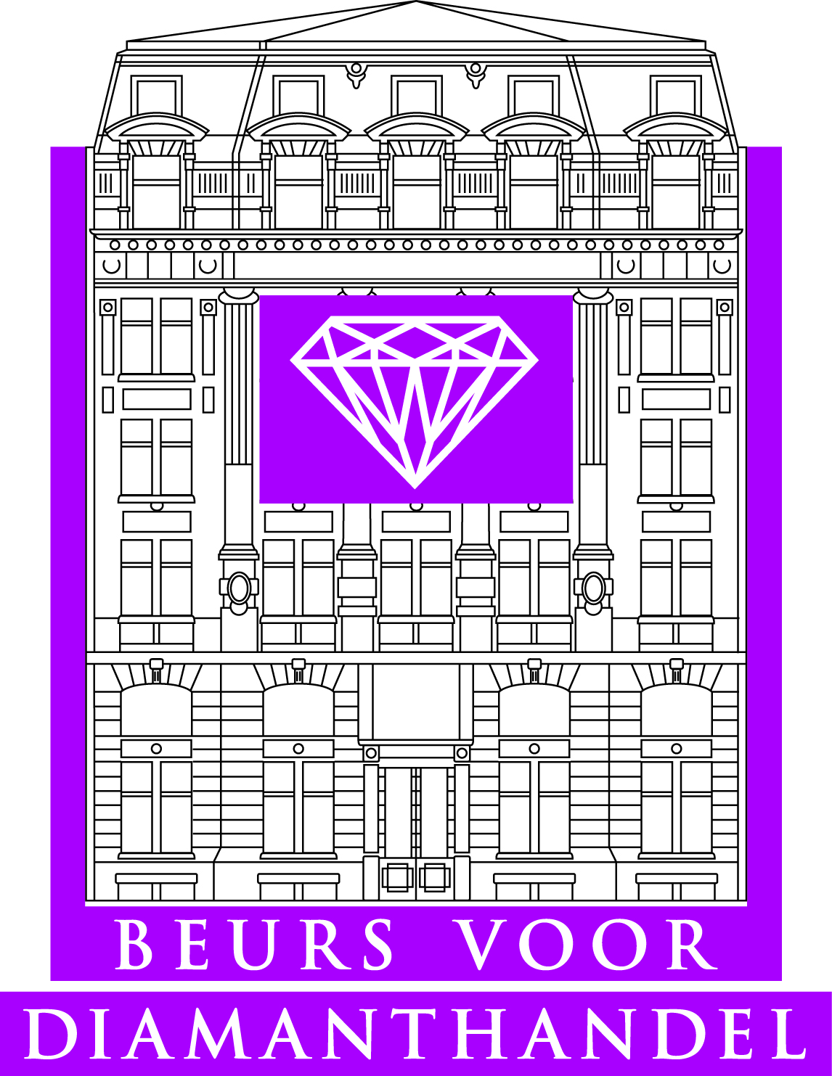
15 OKTOBER 2013
INSCHRIJVINGSFORMULIER / registration form
Voor 25 september 2013 aan het secretariaat van de Beurs voor Diamanthandel terug te bezorgen (email: info@diamondbourse.be, fax : 03 233 65 03)
Please submit this registration form before September 25, 2013 at the Secretariat of the Beurs (email : info@diamondbourse.be, fax : 03 233 65 03)

Gelieve volgende gegevens duidelijk in te vullen / please fill out the following details
NAAM FIRMA : ………………………………………………………………………………………………………………………………………….
company name :
ZAAKVOERDER : ………………………………………………………………………………………………………………………………………..
Director of the company :
ADRES FIRMA : ………………………………………………………………………………………………………………………………………….
Company address :
TELEFOON : ………………………………………………………………………………………………………………………………………………
Phone number :
FAX : …………………………………………………………………………………………………………………………………………………………
E-MAIL : …………………………………………………………………………………………………………………………………………………….
CONTACTPERSOON : …………………………………………………………………………………………………………………………………
Contact person :
PERSONEN DIE DE ZAAK VERTEGENWOORDIGEN OP DE FAIR :
Those representing the company at the fair are :
- ……………………………………………………………………………………………………………………………………………………..
- ……………………………………………………………………………………………………………………………………………………..

Datum en handtekening/Date and signature

