Customer Outreach Tool (COT)
You can share this document with your customer to (1)create his account and (2)complete his KYC information in KYCP and upload the required identification documents, but a link to this guide will also be included in the system-generated e-mail that is sent to the client.
FIRST E-MAIL received by client
The COT user will receive a system generated email to a create username and password.
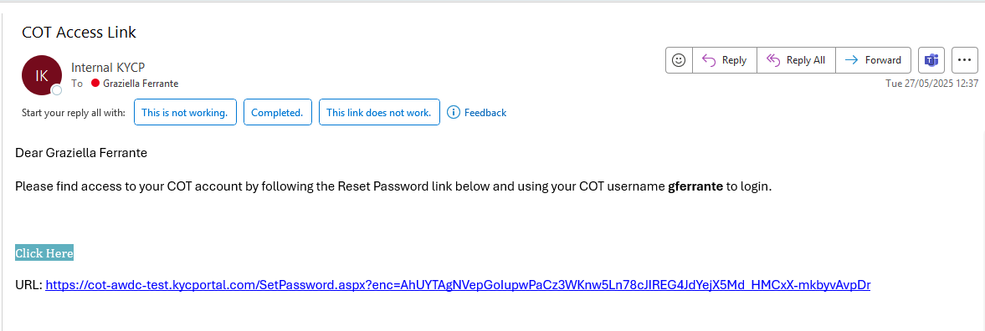

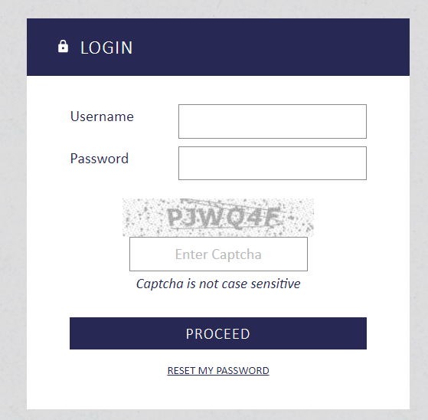
NB – The COT user would have to use the 2-step authentication. There are 3 choices via SMS, email or the user’s preferred authenticator.
SECOND E-MAIL received by client
The COT user will receive a system generated email with a notification that an application has been assigned to them.

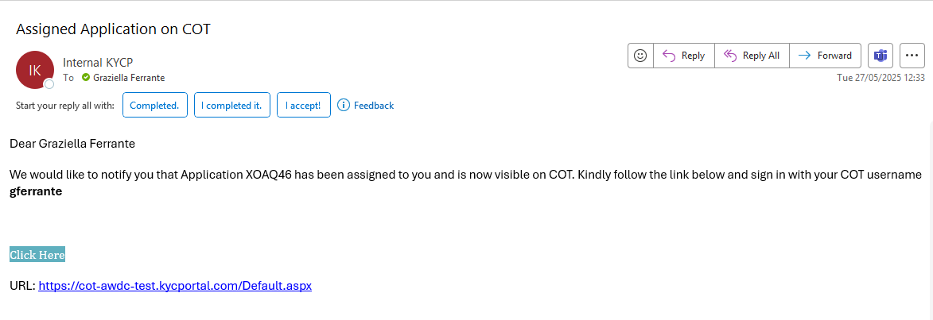
After accessing the link provided in the email, the COT user would need to insert the username and password created earlier.

In the dashboard, the COT user will be able to see all the applications they’ve been assigned to. When selecting the ‘pen icon’ , the user will be able to work on the assigned application.
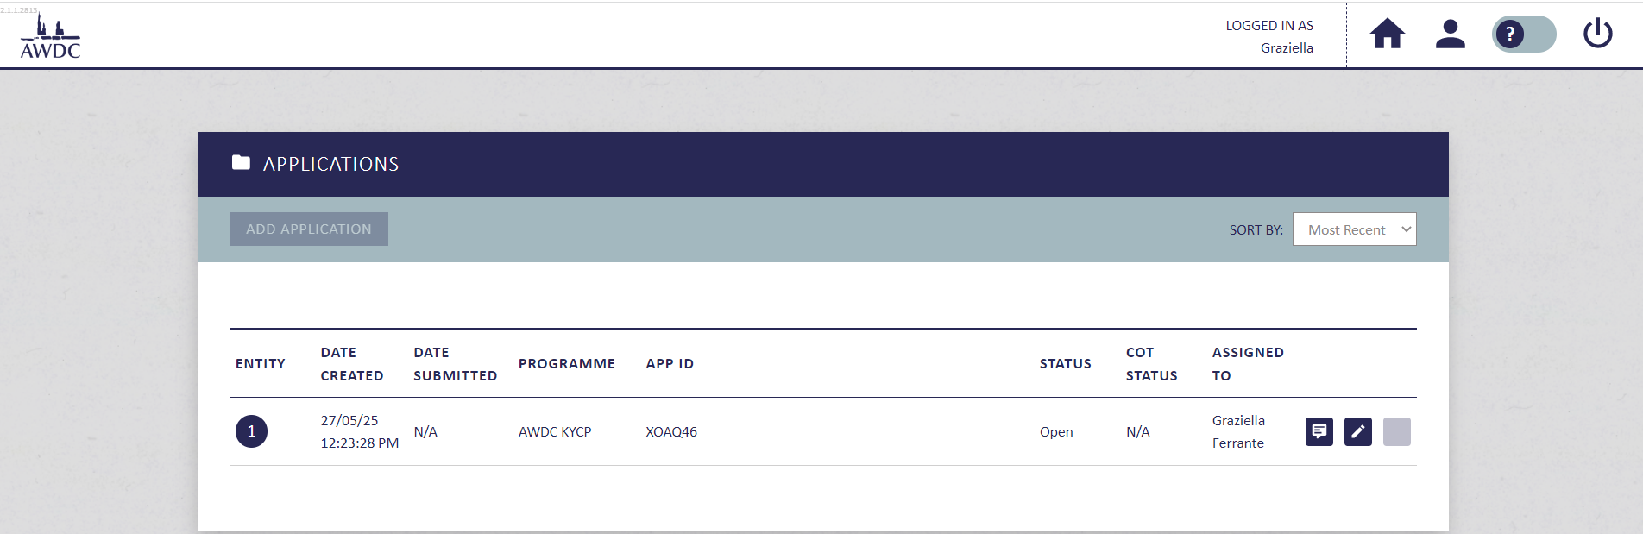
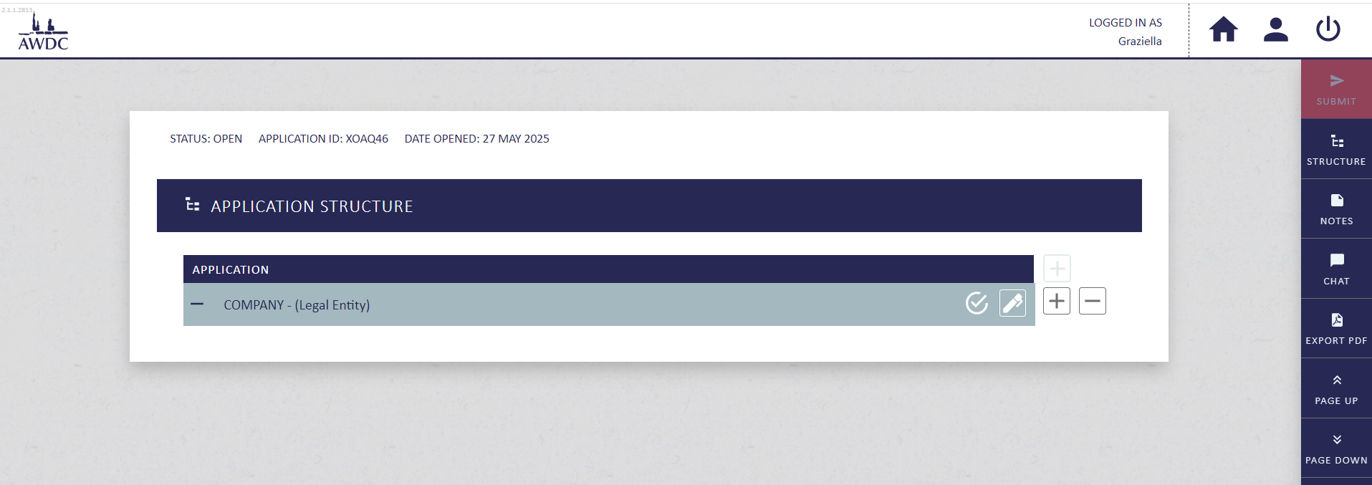
E.g. - by clicking on the '+' icon, the COT user would be able to add more entities
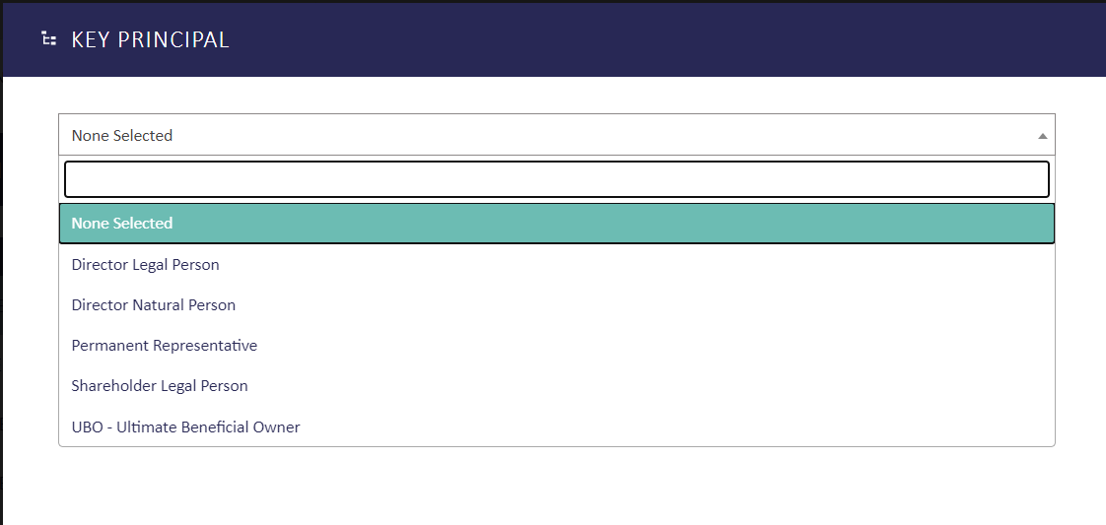
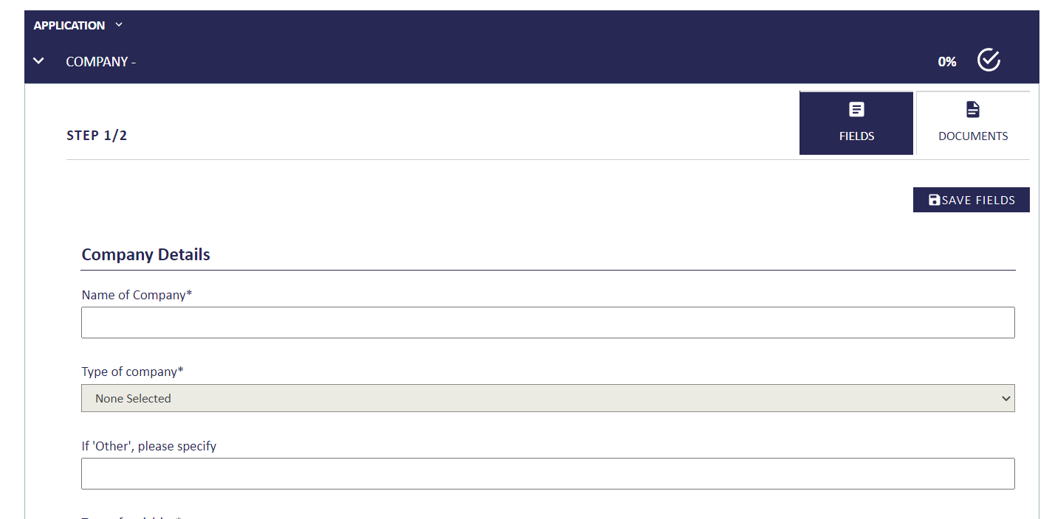
The COT user can fill out any missing details for all the entities within the structure
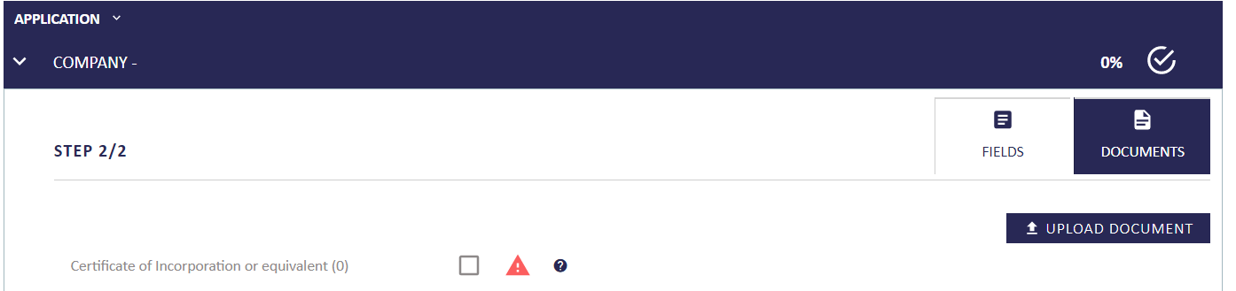
And upload any missing mandatory fields
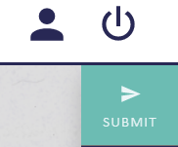
When the COT user has finished filling out all mandatory fields/documents, they will be able to press on ‘Submit’ back to KYCP.
The system will alert the COT user if any mandatory fields and/or documents have been left out, in which case, the COT user would not be able to submit unless all the list provided hasn’t been addressed.
