How to onboard a new company in KYCP

Use Chrome -> go to https://kycp-awdc-prod.kycportal.com/ -> log in with the credentials provided to you by KYCP. Don’t have login credentials yet? Contact trst@awdc.be

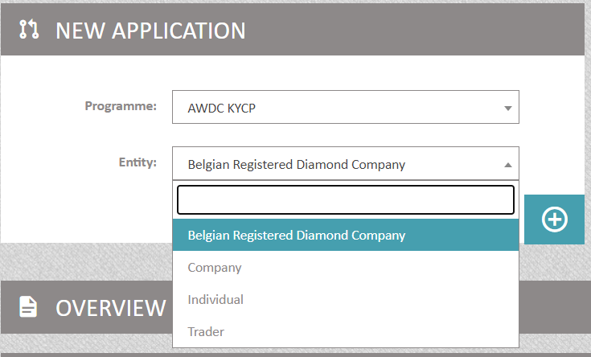

- Belgian Registered Diamond Company: If your client is a local Belgian registered diamond.
- Company: If your client is a company (Belgian or foreign, but NOT a Belgian registered diamond company).
- Individual: If your client is a natural person (a private person).
- Trader: This is the KYC page of your own company. Once you complete the fields, you can export the KYC information PDF format. This can be a useful to share with your bank or other stakeholders that need your KYC information.

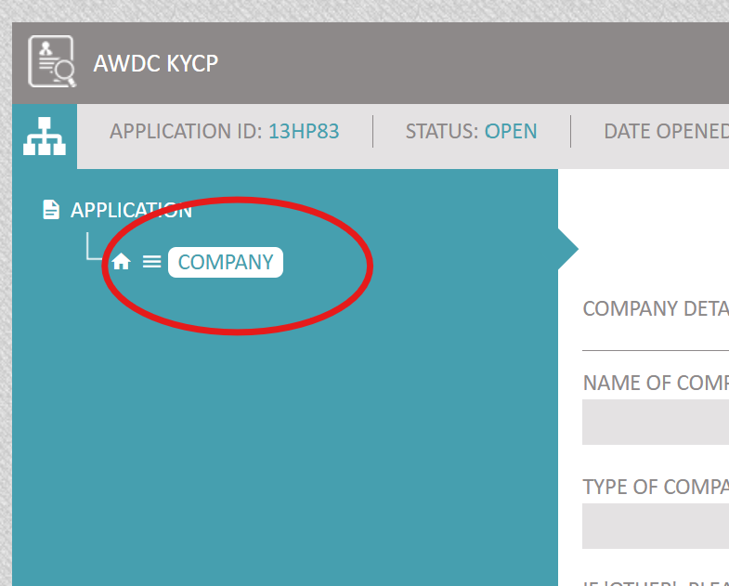
- First click on the selected entity (company, or Belgian registered diamond company or individual) on the left side in the dark blue field

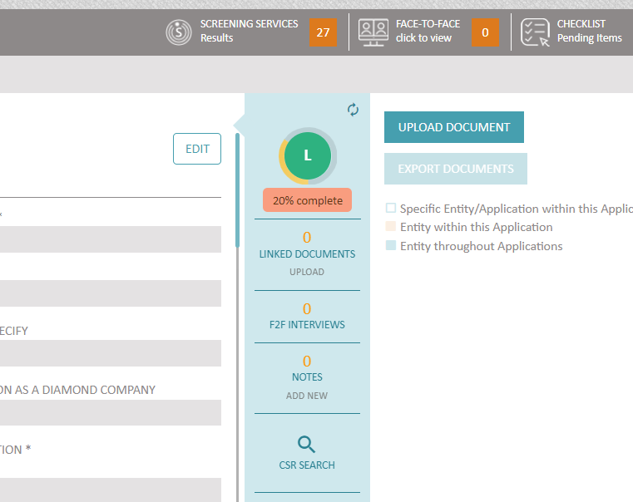

- Then look for the entity in Orbis by pressing 'CSR SEARCH' (see red circle on picture)
- A separate webpage opens
- Enter the company name (field: ‘name’) you are looking for and select the right company (by clicking on the ‘eye’ icon)
- Review the company details (address etc) , also select the PDF Orbis format (obligatory for clients that are Belgian Registered Diamond Companies (!)) and monitoring if you wish -> press IMPORT
- Proceed to structure (select or de-select errors if necessary) and press IMPORT STRUCTURE
- Go back to your KYCP dashboard (different webpage) and REFRESH your webpage (Orbis data are integrated in your application – visible on the left side in the dark blue field)
- Your ORBIS report PDF will also be visible on the right side of the screen.

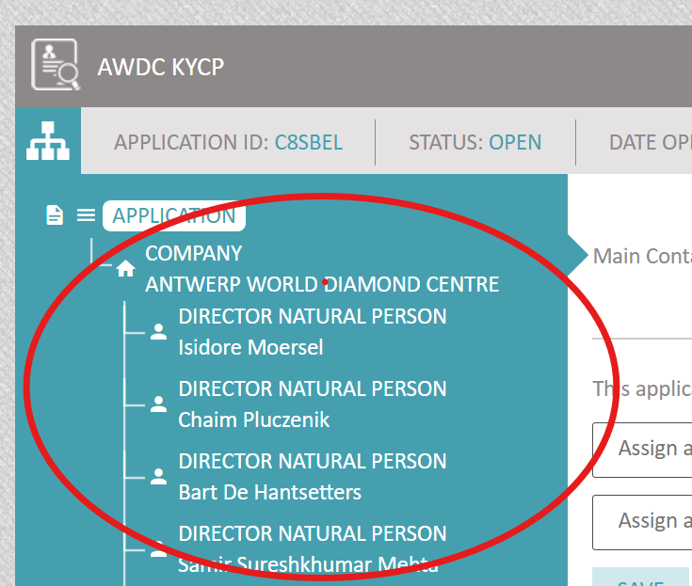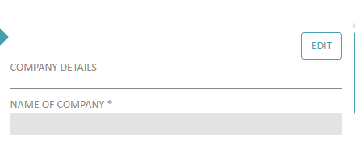
- Click on each entity (entity = the company, directors and UBO’s) separately. To complete the fields (click on EDIT) If you don’t have any company information on your client yet, you can leave these fields blank,and let your client complete them via the Customer Onboarding Tool (see next steps).
- You will notice some questions under the title ‘screening service’: these will be automatically populated by the GRID screening tool. We recommend to leave these fields blank for now and we revisit these fields later in this guideline.
- You will also notice some questions under the title ‘risk assessment’. We recommend to leave these fields blank for now and we will revisit these fields later in this guideline.

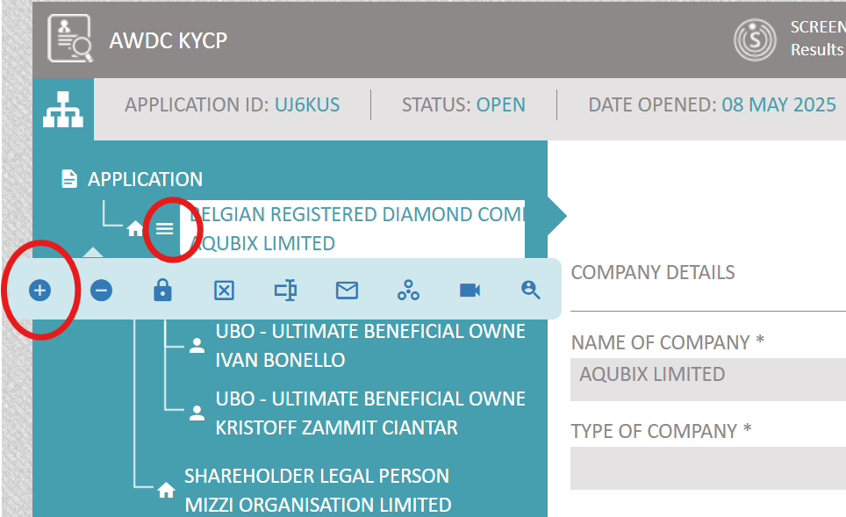

- If you want to add additional directors and/or UBO’s because they were not downloaded (correctly) from ORBIS, click on the 3 lines and click on + (see red circles)
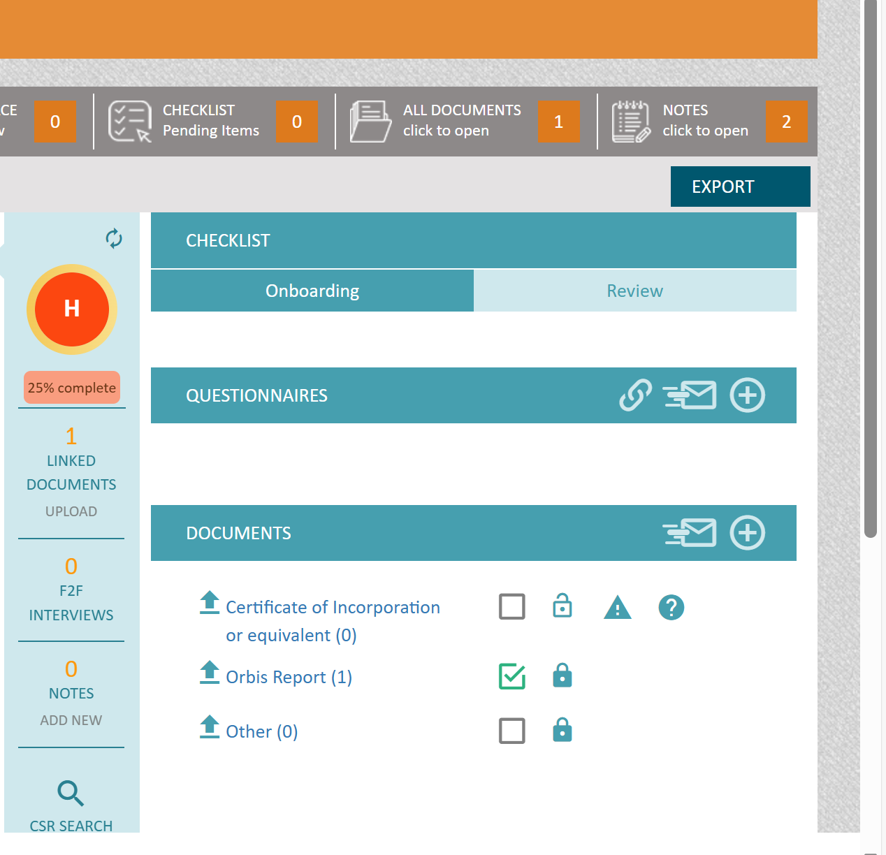

- To upload documents, first click on the left side on the name of the company or on the names of the directors or UBO’s, depending for which entity you want to upload documents and secondly click on ‘checklist’. If you want to change entity, click again on the name of another entity and again on checklist.
- The Orbis report is automatically downloaded if you did the CSR search, for Belgium the Orbis report subtracts its information from the Belgian KBO register so in principle you do not have to check the KBO register separately for Belgian companies
- To upload a document, click on the arrow on the left side pointing upwards, and you will notice that after the upload you will have to edit the document by adding an expiry date.

- Part of the process is to share the application with your client so he/she can complete the KYC information and upload all required documents (ID cards, bylaws,..)..
- 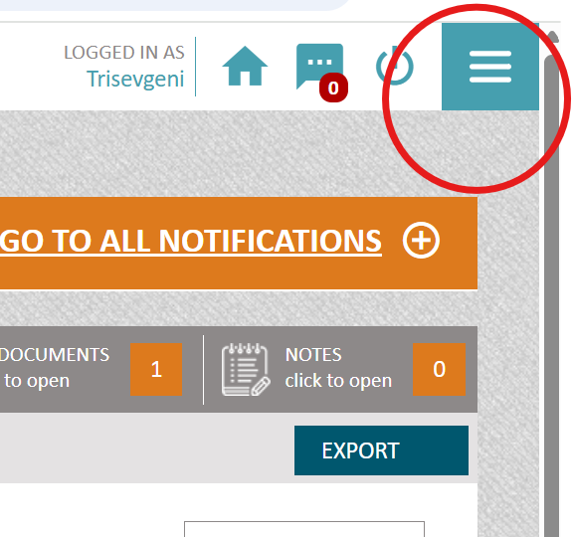

- First you need to create a COT user account for your client in order for him/her to be able to create a username and password: Go to the right top side of your screen and click on the 3 lines.
- Then a blue box will appear, scroll down and select COT USERS

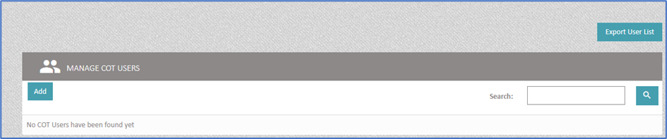

- Select ‘ADD’
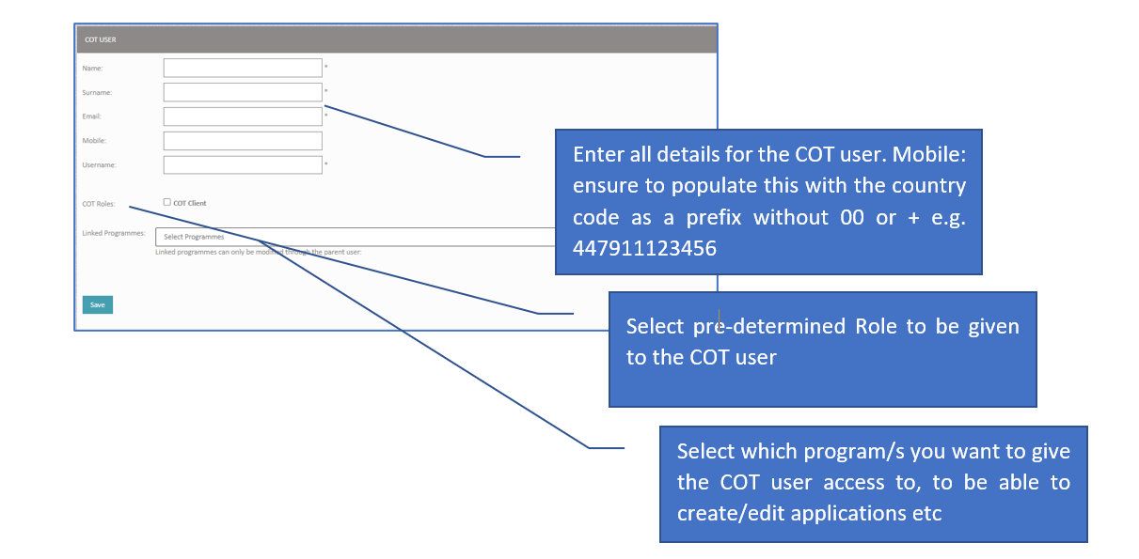
- Username creation: This should be ONE word. We advise to make a combination of your company name and the clients company name.
- Select your Program
- On pressing SAVE, additional fields will pop up, but do not need to be completed if not applicable.
- After pressing SAVE again, a system generated email will be sent to the COT user (client) informing him that a user account was created.

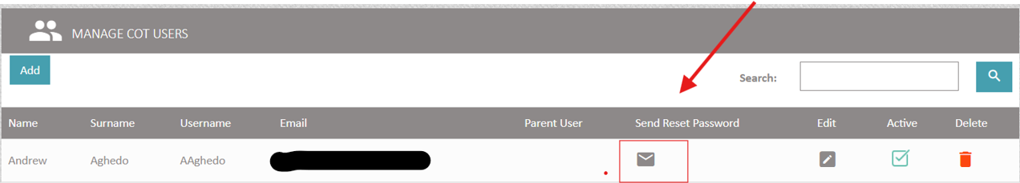

- Then the system will take you to the list of COT users.
- For the new AND existing COT Users, to be able to reset their password (this applies for NEW COT users as well), scroll or use the ‘Search’ filter to choose the correct COT user and press on ‘SEND RESET PASSWORD. The COT user will receive a link to reset the password and will have to log in to COT with the given username following the 2-step authentication.

- 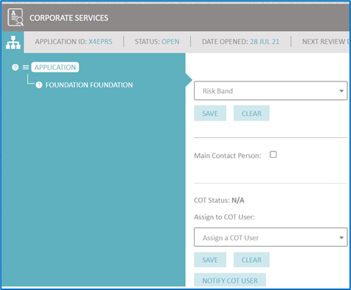

- First click on ‘application’ on the left top side of your screen (dark blue field)
- At, Application level, assign a COT user : select the e-mail address of your client that will receive the e-mail to upload the KYC information and press ‘Save’

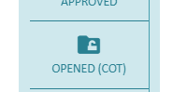

- Select ‘OPENED (COT)’ in the middle part of your screen

- Finally click again on ‘Notify COT User’.
- Your client will receive an invite ( a second e-mail) to complete his KYC information and a link to a guidance doc will be included in the e-mail.
- When the COT user has finished filling out all mandatory fields/documents, they will be able to press on ‘Submit’ back to KYCP and you will get notified by e-mail.

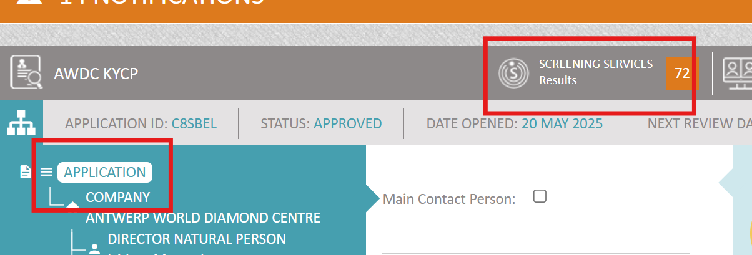
- First click on ‘application’ on the left side in the dark blue field
- Then click on ‘screening services’

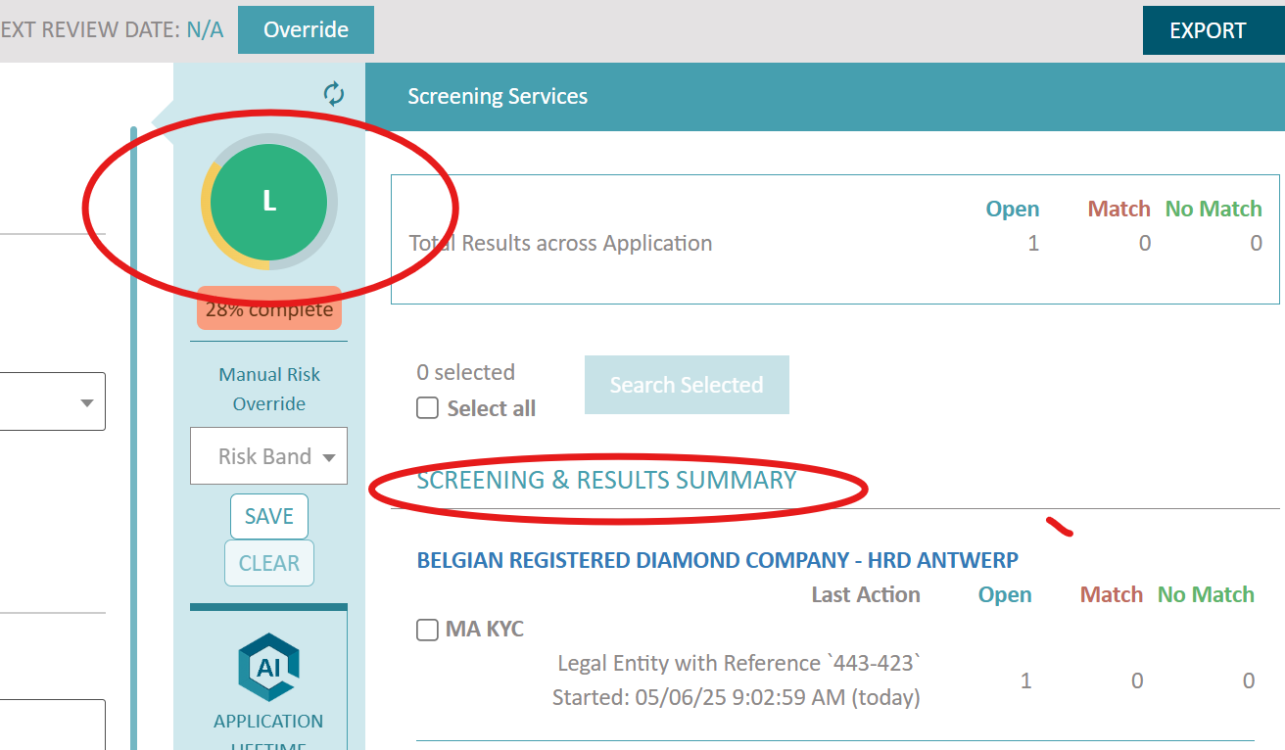

- On the right side you will notice the ‘screening & results summary ‘appear [ sometimes this can take a few minutes, refresh regularly by clicking on the coloured (green, orange or red) risk circle in the middle!]
  - Open= means how many potential matches the system has
  - Match= a number will only appear if you accepted a potential match
  - NO match= a number will only appear if you rejected a potential match
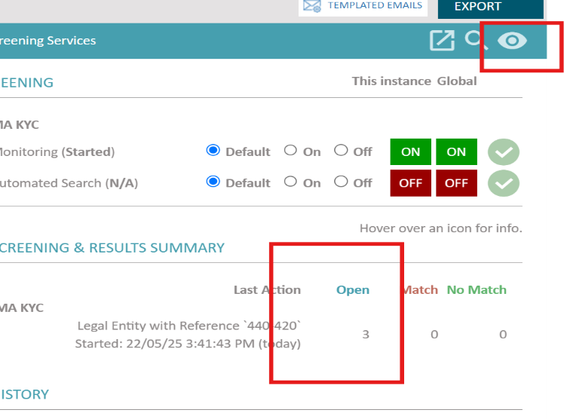
- In this example, you can see 3 potential matches. Click on the eye in the top right corner (depending on what entity you have selected, the eye may not always be visible, but the company name or directors in the screening & results history name might then be ‘clickable’ instead.
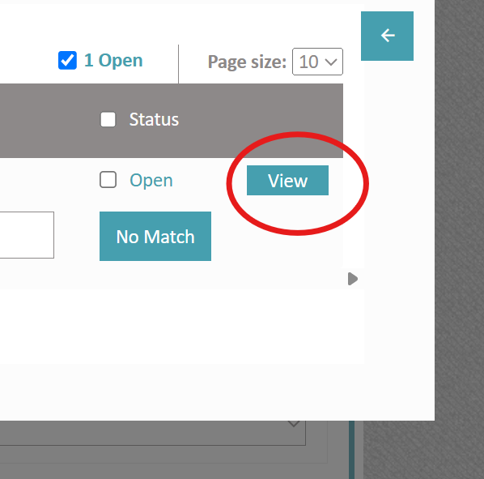

- A separate webpage opens
- Click on VIEW
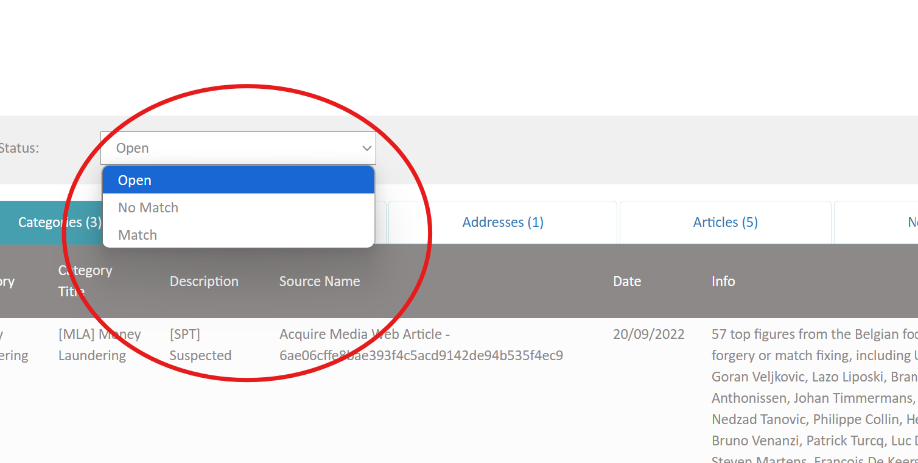

- Go through the potential matches, read them and select MATCH or NO MATCH and click on UPDATE

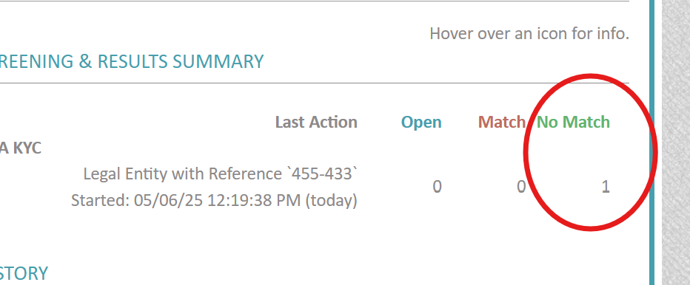

- Go again to your KYCP webpage, refresh the webpage and go to screening services: accepted or rejected matched should be visible now

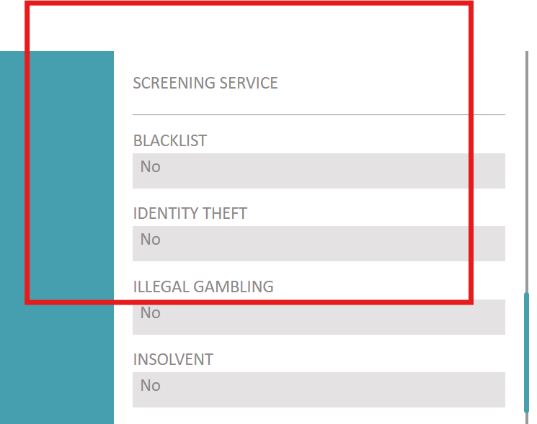

- The field under ‘screening service’ when you click on ‘company’ (left top side in dark blue field), will now also be automatically completed (sometimes you need to refresh multiple times!)

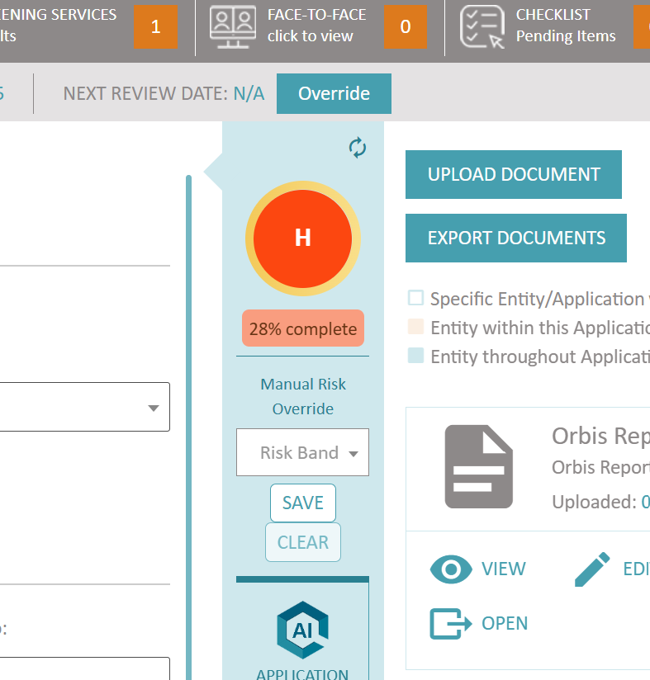
- The risk screening may have impacted the risk score of your client. The risk score is indicated in the middle of your screen: a green circle (low risk), orange circle (medium risk), red circle (high risk).
- You can manually override your risk score by clicking on ‘risk band’ and selecting a different risk scoring (low, medium, high)
- Regularly refresh your risk scoring by clicking on the two arrows on the right top side of the circle

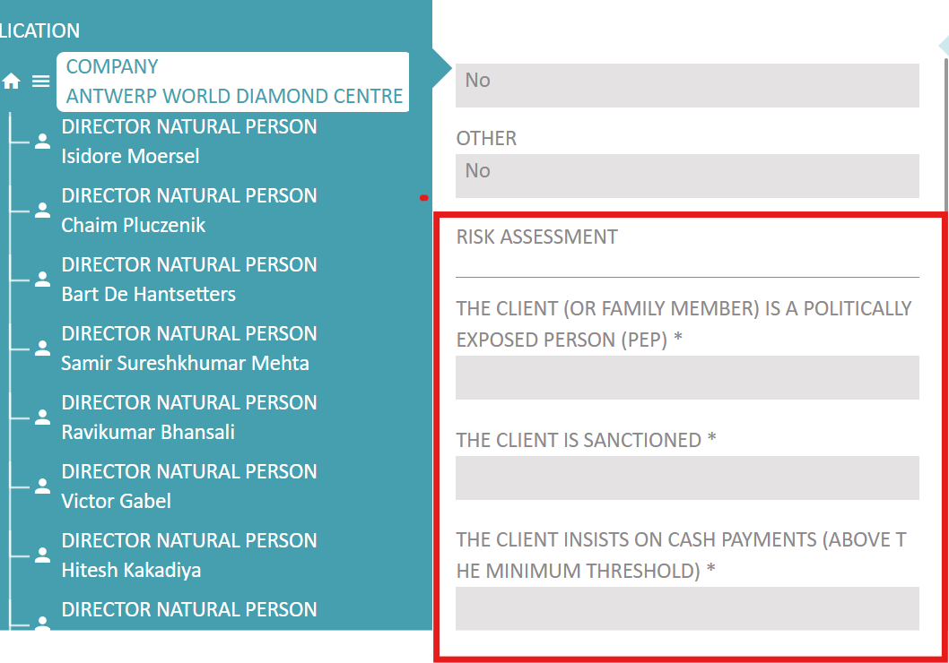

- Click on the name of the company on the left side in the dark blue field
- Complete the risk assessment questions by clicking on EDIT first
- Your answers to these questions may impact your risk scoring again (refresh the coloured circle in the middle of your screen regularly)

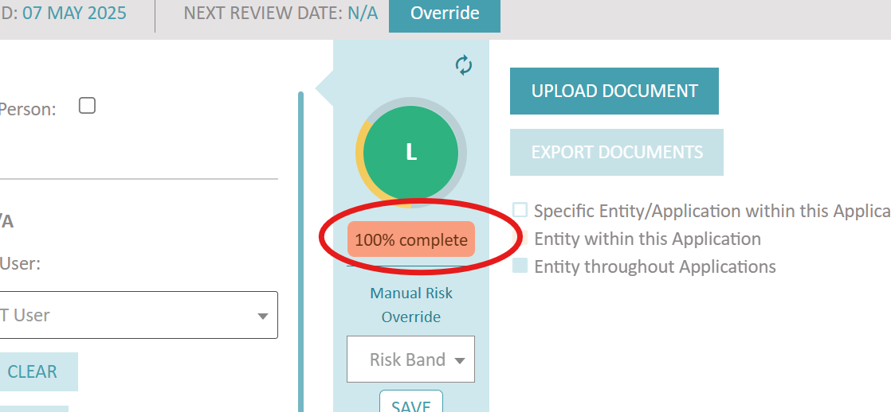
- Click on application (left top side dark blue field) and check the % of completeness of your onboarding. If not 100% complete, you can click on the field ( red circle on screenshot) and it will indicate which fields you still need to complete.

- We recommend to refresh and consult one last time your risk assessment scoring.
- Understand that you can manually override your risk scoring, but you need to motivate why.
- Click on application (top left on your screen, dark blue field)

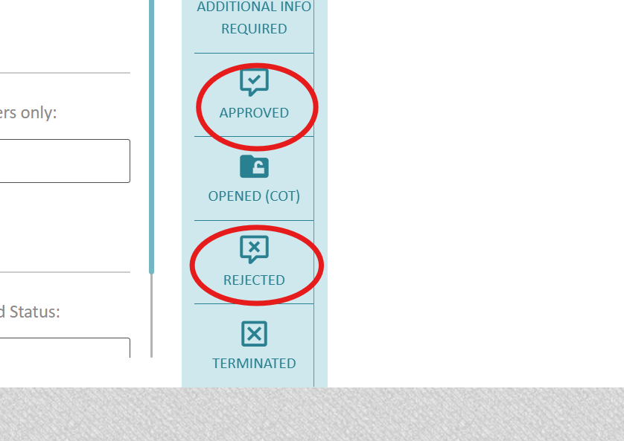
- On the middle band of your screen (sometimes you need to scroll down!!), you can click on ‘APPROVED’ or ‘REJECTED’ and leave a comment why you accepted or rejected the client

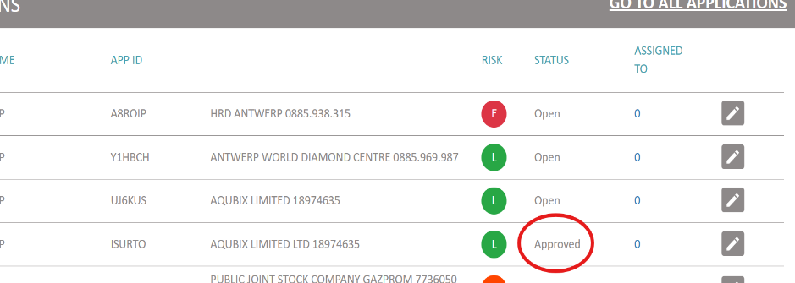

- In your overview page of all your applications, you will get an overview of the status of all your applications (rejected, approved, open)

